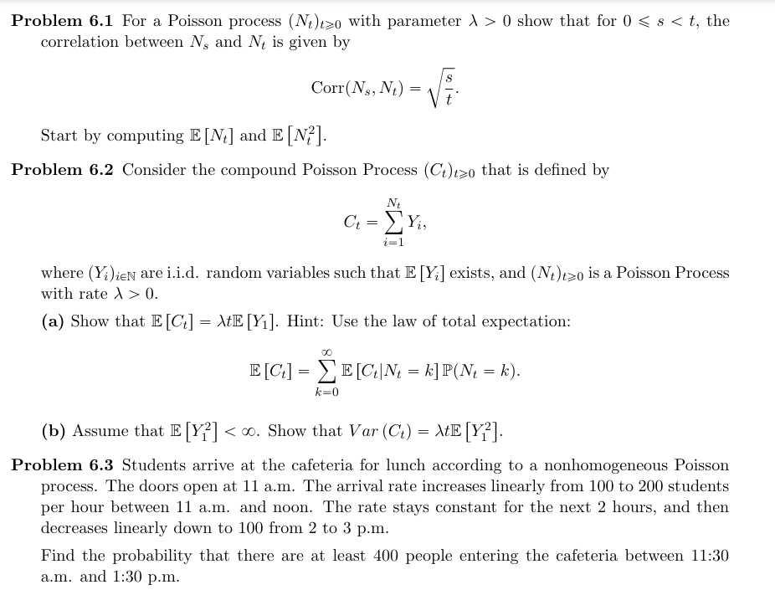

{"type":"lalign*","code":"\\begin{lalign*}\n&{\\text{let}\\;\\left(N_{t}\\right)_{t\\geq0}\\;\\text{be}\\;\\text{a}\\;\\text{pois}\\;\\text{process}\\;\\text{with}\\;\\text{parameter}\\;\\lambda>0}\\\\\n&{}\\\\\n&{E\\left[N_{t}\\right]=\\sum_{x=1}^{\\infty}x\\cdot \\frac{e^{-\\lambda}\\left(\\lambda t\\right)^{x}}{x!}=\\lambda t\\sum_{x=1}^{\\infty}\\frac{e^{-\\lambda}\\left(\\lambda t\\right)^{x-1}}{\\left(x-1\\right)!}=\\lambda t\\sum_{x=0}^{\\infty}\\frac{e^{-\\lambda}\\left(\\lambda t\\right)^{x}}{\\left(x\\right)!}=\\lambda t}\\\\\n&{}\\\\\n&{E\\left[N_{t}^{2}-N_{t}\\right]=E\\left[N_{t}^{2}\\right]-E\\left[N_{t}\\right]=\\sum_{x=1}^{\\infty}x\\left(x-1\\right)\\frac{e^{-\\lambda}\\left(\\lambda t\\right)^{x}}{x!}=\\sum_{x=1}^{\\infty}\\frac{e^{-\\lambda}\\left(\\lambda t\\right)^{x-2}\\cdot \\lambda^{2}t^{2}}{\\left(x-2\\right)!}=\\lambda^{2}t^{2}}\\\\\n&{E\\left[N_{t}^{2}\\right]-E\\left[N_{t}\\right]=\\lambda^{2}t=E\\left[N_{t}^{2}\\right]-\\lambda t}\\\\\n&{\\c{ff0000}{E\\left[N_{t}^{2}\\right]=\\lambda^{2}t^{2}+\\lambda t}}\\\\\n&{}\\\\\n&{\\text{since}\\;\\text{this}\\;\\text{is}\\;\\text{a}\\;\\text{poiss}\\;\\text{distrib}\\;\\implies\\text{var}\\left(N_{t}\\right)=E\\left[N_{t}\\right]}\\\\\n&{\\c{ff0000}{\\text{var}\\left(N_{t}\\right)=\\lambda t}}\\\\\n&{}\\\\\n&{E\\left[N_{s}\\cdot N_{t}\\right]=\\sum_{k=0}^{\\infty}\\sum_{j=0}^{\\infty}P\\left(N_{s}=k,N_{t}=j\\right)\\cdot k\\cdot j=\\sum_{k=0}^{\\infty}\\sum_{j=0}^{\\infty}P\\left(N_{s}-N_{0}=k,N_{t}-N_{s}=j-k\\right)\\cdot k\\cdot j}\\\\\n&{E\\left[N_{s}\\cdot N_{t}\\right]=\\sum_{k=0}^{\\infty}\\sum_{j=0}^{k}P\\left(N_{s}=k,N_{t}=j\\right)\\cdot k\\cdot j=\\lambda s+\\lambda s\\cdot \\lambda t}\\\\\n&{}\\\\\n&{\\text{Corr}\\left(N_{s},N_{t}\\right)=\\frac{E\\left[N_{s}\\cdot N_{t}\\right]-E\\left[N_{s}\\right]\\cdot E\\left[N_{t}\\right]}{{\\sqrt[]{\\text{var}\\left(N_{s}\\right)\\cdot\\text{var}\\left(N_{t}\\right)}}}=\\frac{\\lambda s}{{\\sqrt[]{\\lambda t\\cdot\\lambda s}}}={\\sqrt[]{\\frac{s}{t}}}}\\\\\n&{}\\\\\n&{}\t\n\\end{lalign*}","backgroundColorModified":false,"id":"1","backgroundColor":"#ffffff","aid":null,"font":{"family":"Arial","size":10,"color":"#000000"},"ts":1716144687616,"cs":"7789fxAOvTQbJytCZvfREw==","size":{"width":644,"height":460}}



